**1:**

**package** pkg_00000_ClassWork;

**public** **class** LoopForRectange {

**public** **static** **void** main(String args[]) {

**int** row, col;

/*

* 8x12 Rectangle with Letter 'R'

*/

**for** (row = 0; row < 4; row++)

{

**for** (col = 0; col < 6; col++)

{

**if** (row > 0 && col > 0 && row != 3 && col != 5)

{

System.***out***.print(" "); /* 2 spaces */

}

**else**

{

System.***out***.print("R ");

}

}

System.***out***.println();

}

}

}

R R R R R R

R R

R R

R R R R R R

**2:**

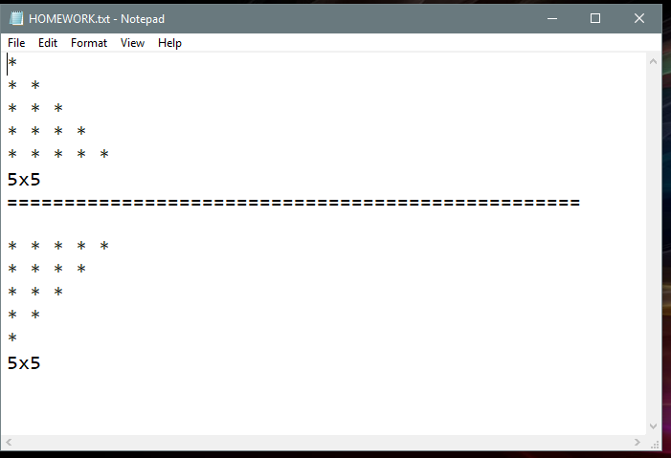

**3:**

**package** pkg_1_Basics;

**public** **class** Session4_1IntroToClass

{

**public** **static** **void** main(String[] args)

{

System.***out***.println("Program begins Here");

Session4_1IntroToClass myclass = **new** Session4_1IntroToClass();

**int** a = myclass.add(20,100,50);

System.***out***.println("The answer of addition ==> " +a );

**int** b = myclass.sub(25,40);

System.***out***.println("The answer of subtraction ==> " +b);

System.***out***.println("Program Ends Here");

}

**public** **int** add(**int** x, **int** y, **int** z)

{

**int** c = x + y + z;

**return** c;

//System.out.println("The answer of addition ==> " +c);

}

**public** **int** sub(**int** x, **int** y)

{

**int** z = x - y;

**return** z;

//System.out.println("The answer of subtraction ==> " +z);

}

}

**4:**

**package** pkg_1_Basics;

**public** **class** ClassAndObjectDemo {

String Fname;

String Lname;

String Result;

**void** concat(String a, String b)

{

Fname = a;

Lname = b;

Result = Fname+ " "+Lname;

}

**void** printout()

{

System.***out***.println("The Result = " +Result);

}

**public** **static** **void** main(String[] args)

{

ClassAndObjectDemo obj1 = **new** ClassAndObjectDemo();

ClassAndObjectDemo obj2 = **new** ClassAndObjectDemo();

obj1.concat("John","Smith");

obj1.printout();

obj2.concat("Queen","Elizabeth");

obj2.printout();

}

}

**5:**

**package** pkg_1_Basics;

**public** **class** ClassAndObjectDemo {

String Fname;

String Lname;

String Fullname;

**void** concat(String a, String b)

{

Fname = a;

Lname = b;

Fullname = Fname+ " "+Lname;

}

**void** printout()

{

System.***out***.println("The Result = " +Fullname);

}

**public** **static** **void** main(String[] args)

{

ClassAndObjectDemo obj1 = **new** ClassAndObjectDemo();

ClassAndObjectDemo obj2 = **new** ClassAndObjectDemo();

//obj1.concat("John","Smith");

//obj1.printout();

obj1.concat("Queen","Elizabeth");

obj2.concat("Sheila","Elizabeth");

obj1.printout();

obj2.printout();

}

}

**6:**

**package** pkg_1_Basics;

**public** **class** ClassAndObjectDemo {

String Fname;

String Lname;

String Fullname;

**int** c;

String concat(String a, String b)

{

Fname = a;

Lname = b;

String name = Fname+ " "+Lname;

**return** name;

}

**int** method1(**int** a, **int** b)

{

c = a+b;

**return** c;

}

**void** printout()

{

System.***out***.println("The Result = " +Fullname);

}

**public** **static** **void** main(String[] args)

{

ClassAndObjectDemo obj1 = **new** ClassAndObjectDemo();

ClassAndObjectDemo obj2 = **new** ClassAndObjectDemo();

String answer = obj1.concat("John","Smith");

//obj1.printout();

System.***out***.println("Answer = "+answer);

String Result = obj1.concat("Queen","Elizabeth");

obj2.concat("Sheila","Elizabeth");

**int** x = obj1.method1(45, 50);

System.***out***.println("The value of addtion (method1) = "+x);

obj1.printout();

obj2.printout();

}

}

**7:**

**Home Work**

**create a class with 5 methods.**

**method1 will return the result of addition of 2 int numbers.**

**method2 will return the result of subtraction of 2 float numbers.**

**method3 will return the result of multiplication of 3 double numbers**

**method4 will return the result of the number of characters in a String.**

**hint:**

**for method1, you can write it as follows:**

**int method1(int a, int b)**

**{**

**int c = a+b;**

**return c;**

**}**

**int myresult = obj1.method1(2,3);**